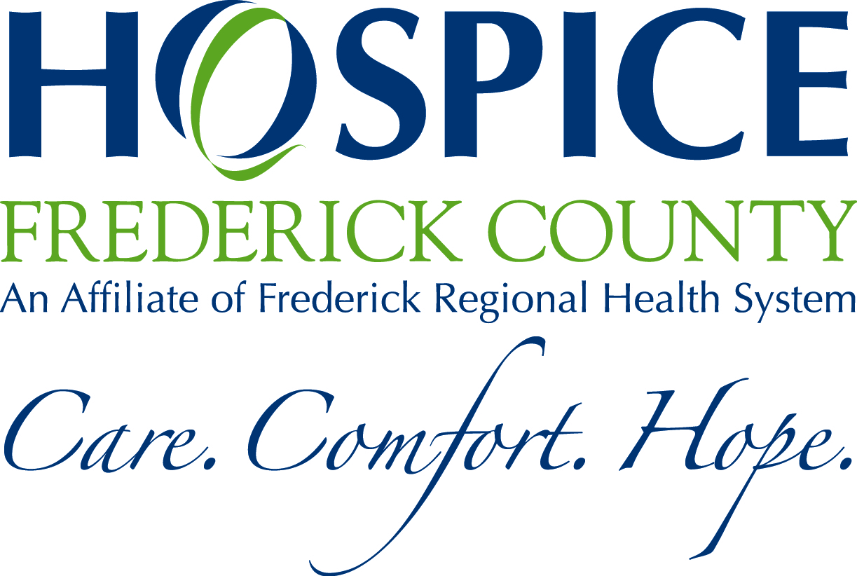
Frequently Asked Questions

What is Team Hospice?
Team Hospice is a group of community members who want to help raise money for Hospice of Frederick County while having fun and getting exercise. You don’t have to be a runner to join Team Hospice. We welcome walkers.
How do I join Team Hospice?
You can join Team Hospice by emailing Jess Mitko at jmitko@fmh.org. She can send you all the necessary paper work to get you registered for the Frederick Running Festival. However, you have to commit to raise a minimum of $275 to join the team. That includes your race entry and team t-shirt. The more money you raise, the more incentives you can earn!
What race experience do I need to join the team?
None! Some of our team members do marathons and half marathons, others do mile races. You do need to commit to either the 5k (3.1miles) team relay (7.6 or 5.5 miles) or half marathon (13.1 miles). Once again you can walk or run.
Will there be team trainings?
Yes. Join the Team Hospice closed Facebook Group. We will post team training tips, group trainings, and much more to get you ready for race day.
What’s the easiest way to fundraise and meet my goal?
First, I would ask friends and family either through a personalized email or phone call. Second I would share on any and all social media platforms. Facebook is great fundraising tool especially if you can share personalized stories or accomplishments. Lastly, approach local restaurants to do a “give back night.” Everyone has to eat and what better way than to support a friend or local charity. Don’t forget to ask your company if they do matching donations!!
How can I accept donations?
The easiest way is to join the youcare.com site. This allows you share through email and social media. You can also let your supporters know why you are raising money for Hospice. You can also collect cash and check. Those can be mailed to Hospice of Frederick County at PO Box 1799, Frederick, MD 21702. Please make sure to include your name. Jess will keep a master tally of team fundraising progress. Checks can be made out to Hospice of Frederick County.
Will there be Team Fundraisers to help Team Members out?
Yes. Hospice of Frederick County is here to help. Team fundraisers will be organized periodically that team members can participate in to help reach their personal goals. Hospice of Frederick County can also use their social media accounts to help promote your personal fundraisers as well.

